**TYPE OF WATER SUITABLE FOR A CORN PLANT**

**by**

Nicole Faith Sabado Carolino

Raylene Audrey Alegre Diolata

Clarenz Polo Beltran Ocampo

Hazel Anne Carog Quirao

Ma. Angelika Alipio Silapan

SUBMITTED TO THE FACULTY OF **CALAMBA CITY SCIENCE HIGH SCHOOL** IN PARTIAL FULFILLMENT TO THE REQUIREMENTS IN

RESEARCH II

NOVEMBER 2012

**Bibliographic Sketch**

The researchers are Nicole Faith Carolino, daughter of Analiza and Antonio Carolino, born on June 4, 1998, graduated in Morning Star Montessori Center. Raylene Audrey Diolata, born on July 18, 1999, graduated in Mayapa Elementary School. Clarenz Polo Ocampo born on November 17, 1998, the son of Florita and Roehl Ocampo graduated in Laguna College of Business and Arts. Hazel Anne Quirao, daughter of Jose Harry and Mary Jane Quirao, born on Sepetember 26, 1998 and now living in Villa de Calamba, graduated in Calamba Elementary School. Ma. Angelika Silapan born on March 5, 1999, the daughter of Alicia and Rolando Silapan graduated at Liceo de Calamba living in Ilayan, Parian, Calamba City, Laguna.

These young researchers have been studying hard since they started which got them to where they are today. They started as simple classmates and nothing much to ones attention but in the end, after all the hardships and struggles, they ended up as good and trust-worthy friends to each other. They aim to be a better person in the upcoming future to reach the goals in life they desire.

**Acknowledgement**

The researchers are Nicole Faith Carolino, Raylene Audrey Diolata, Calrenz Polo Ocampo, Hazel Anne Quirao and Ma. Angelika Silapan. They have done this research without worries because of the people who helped them in their conflicts. The researchers would like to give thanks to:

Almighty God for supporting them each day, and giving another chances in every failures.

Mrs. Melanie M. Samudio, for her guidance, the information, and the knowledge that she had given the researchers, that they would surely remember all through their lives.

. Heunice Kyle Oracion and John Kenneth Fulgencio for giving them a helping hand in completing this research.

The researchers also would like to thank each other for the hard work that each individual had given, the teamwork that they have shown, and the fun they had experienced while doing this research.

To all the people the researchers hadn’t mentioned, your names are already written in their heart.

Table of Contents

Title Page ………………………………………………………………….………………i

Bibliographic Sketch …………………………………………………………….……….ii

Acknowledgement …………………………………………………………………….…iii

Table of Contents ………………………………………………………………………...iv

List of Table ……………………………………………….………………………v

List of Figures ……………………………………………………………………………v

Abstract …………………………………………………………………………………..vi

1. Introduction ……………………...…………………………………………....1

Background of the Study ………………………………………………...………..1

Statement of the Problem …………………………….………………………..…..3

Hypotheses ………………………………………….………………………..……4

Significance of the Study ………………………….………………………..……..4

Scope and Limitation …………………………….………………………..………4

Conceptual Framework ………………………….…………….………….……….5

Definition of Terms ………………………………………………………………………6

1. Review of Related Literature …………………………………….…………...7
2. Methodology …………………………...……………………………........…10

Location of the Study …………...…………………………………………..……10

Instruments ………………………………………………………………..……...10

Data Gathering Process …………...…………………………………………..….10

Statistical Analysis ……………………………………………………………….11

1. Result and Discussion ……...………..………………………………………12
2. Conclusion and Recommendation ………………………..…………………13
3. References …………………………………..……………………………….14
4. Appendices ………………………………………………………………….15

**List of Table**

No. Title Page

*Table 4.1 The measurement of the corn plants’ height in 3 weeks*  12

*Table 4.2 The summary of the computation* 12

**List of Figure**

No. Title Page

*Fig. 1.1 Conceptual Framework* 5

Submitted to Mrs. Melanie Samudio, Research II adviser at Calamba City Science High School, Calamba City, Laguna

Nicole Faith Sabado Carolino

Raylene Audrey Alegre Diolata

Clarenz Polo Beltran Ocampo

Hazel Anne Carog Quirao

Ma. Angelika Alipio Silapan

**Abstract**

The research was about the effects of different types of water to corn plants. The research was conducted in Calamba City Science High School from August to November. The study would test the effect of different types of water such Tap, Distilled and Chlorinated water on the corn plants. This research would give an insight on the type of water that is suitable for corn plants. It will focus on the changes in growth, similarities and difference in their condition upon using the type of waters as said to as tap, distilled and chlorinated water. The researchers used 6 corn seeds and 6 pots. It had been divided into 3 sets: Set A, Set B and Set C. Each corn plants received same amount of different types of water such as tap, distilled, and chlorinated. The researchers recommend to conduct the same study in a different place, and try to make the plants continue grow longer so you can attain a better result.

**Introduction**

**Background of the Study**

Over 3,000 million years ago, the first living-organism which resembled a plant appeared. It was blue - green algae which lived in the sea and can still be found in the water today. When the plants made their first appearance on Planet Earth the atmosphere was unlivable for all oxygen breathing creatures. The air was made out of carbon dioxide, a gas which to us is deadly. Then photosynthetic plants came along and slowly over several million years, cleaned the atmosphere and filled it with oxygen. (http:// www.sakschools.ca/~pvsd/ vsfprojects/foodforlife/www.simplydivinectering.com/history of plants.htm)

There are different kinds of plants. Others bear and others bear fruits. Corn is an example of a fruit- bearing plant. Corn comes from the Latin word ‘maize’ meaning a tall, elongated cereal grass originally domesticated in Mexico and grown widely with long ears of starchy grains; also called Indian corn. (Samsung Galaxy GT- S5360- Miriam Webster Dictionary) It is used as a livestock feed for chickens, pigeons, cows, and even pigs and some are just stored at the silage. One reference lists over 500 different uses for corn. Corn is a component of canned corn, baby food, hominy, mush, puddings, tamales, and many more human foods. Some industrial uses of corn include filler for plastics, packing materials, insulating materials, adhesives, chemicals, explosives, paint, paste, abrasives, dyes, insecticides, pharmaceuticals, organic acids, solvents, rayon, antifreeze, soaps, and many more. Corn is also used as the major study plant for many academic disciplines such as genetics, physiology, soil fertility and biochemistry. It is doubtful that any other plant has been studied as extensively as has the corn plant. (<http://www.agron.iastate.edu/courses/agron212/readings/corn_history.htm>)

Photosynthesis is the food- making process of plants. (Functional Biology Modular Approach, 2010 by Joaquin, Crescencia C. Ph. D.& Lagunzad, Catherine Genevieve B. Ph. D.) Basically, there are two raw materials used in the process of photosynthesis- water and carbon dioxide. Most plants obtain water from the soil. A root system and a network of conducting cells, called xylem vessels found in the stem and leaves, make this possible. Carbon dioxide is normally obtained by plants from the atmosphere, through structures known as stomata. (Second Year Biology Textbook, 1996 by Capco, Carmelita M. & Yang, Gilbert C.) Without water, the food- making process of a plant would be incomplete because it is used for the chemical and biochemical processes supporting plant’s metabolism, then uses carbon dioxide in the air, to make sugar – bear fruit. (<http://www.ehow.com/about_5240957_importance-water-plants.html>)

There are different types of water that can be found in planet Earth. Just like Artesian, Distilled, Fluoridated, Mineral, Purified, Sparkling, Spring, Sterile and Well Water. Artesian Water may also be known as “artesian well water”. The water level in well must stand at some height above the top of the aquifer. Distilled Water is water that has been turned into steams to leave impurities behind. Fluoridated Water contains fluoride that is added within the limitations set by Federal Regulations. Mineral Water must contain no less than 250 parts per million (ppm) total dissolved solids (TDS) with the solids being the minerals in the water. Purified water may also be known as “demineralized water”. It is produced by distillation, deionization, reverse osmosis or other suitable processes that meet the legal definition of “purified water”. Sparkling Water contains, after treatment and possible replacement of carbon dioxide, the same amount of carbon dioxide that it had at emergence from the source. Spring Water must come from underground formation and flow naturally to the surface of the Earth. Sterile Water may also be known as “sterilized water”. It must meet the requirements under “Sterility Test” in the United States Phar Mac PP Copoeia. Last one is Well Water that comes from a hole that is bored, drilled or otherwise constructed in the ground, tapping the water of an aquifer. (http://www.waterforliving.com/files/WaterTypes.htm)

Not only for photosynthesis, water also helps the growth and the life of the plant but too much water leads to water stress. Cell division, the addition of new cells, and cell expansion, the increase of size in cells, are the two ways by which plants grow. No cell division and cell expansion leads to fewer and smaller leaves, smaller fruit, shorter, thicker stems and a smaller root system and eventually it will wilt. Water also regulates the opening and closing of stomata, which in turn regulates transpiration and photosynthesis. If too little water is available to the root system, the plant will reduce the amount of water lost through transpiration. This causes reduced photosynthesis because the necessary carbon dioxide enters the plant through the stomata. Decreases in photosynthesis result in decreased crop yields thus starvation of people. (<http://www.ehow.com/about_5240957_importance-water-plants.html>)

**Statement of the Problem**

The study was about the different types of water suitable for corn plants. The researchers’ wanted to know the effect of the three types of water such as tap, distilled, and chlorinated water on the corn plant’ s growth.

**Hypotheses**

The study deals with the effect of the different types of water such as tap, distilled, and chlorinated water to the corn plants. The researcher’s null hypothesis was, the use of the three types of water has no significant difference on the growth of the corn plants. The alternative hypothesis is that, using the three types of water has significant differences on the growth of the corn plants.

**Significance of the Study**

The study would test the effect of different kinds of water such as tap, chlorinated and distilled on the growth of corn plants. These three types of water were the most common source of water in Calamba.

This study would give an insight on the type of water that is suitable for the corn plant.

**Scope and Limitation**

This research was inclined about how the different types of water may take effect on the growth of the corn plants. It would focus on the changes in growth, similarities and difference in their condition upon using the type of waters as said to as tap, distilled and chlorinated water.

The experiment was conducted in Calamba City Science High School in the month of August 2012 to November 2012. The environmental characteristics may result to a different outcome from the other outcomes that may or will be conducted in different places. The weather in Calamba for the month of August to November is somehow rainy and unpredictable. The air pollution level was also a factor that can vary the results.

**Conceptual Framework**

**TYPE OF WATER SUITABLE FOR A CORN PLANT**

TAP

DISTILLED

CHLORINATED

CORN

EFFECTS

**Definition of Terms**

Agronomy – The application of a combination of sciences like biology, chemistry, economics, ecology, earth science and geneteics

Blue-green algae - types of bacteria known as *Cyanobacteria*. In external appearance and requirements for light, nutrients and carbon dioxide, they are similar to algae. They normally look green and sometimes may turn bluish when scums are dying.

Calcium sulfate - a white odorless crystal or powder. Source: anhydrite, gypsum. Use: drying agent, building material.

F Test - any statistical test in which the test statistic has an F-distribution under the null hypothesis.

Fluoride - the anion F−, the reduced form of fluorine when as an ion and when bonded to another element.

Magnesium chloride – A colorless or white crystalline compound. Use: source of magnesium, in fireproofing, paper making, ceramics, fire extinguishers.

Silage -  [fermented](http://en.wikipedia.org/wiki/Fermentation_(food)), high-moisture [fodder](http://en.wikipedia.org/wiki/Fodder) that can be fed to [ruminants](http://en.wikipedia.org/wiki/Ruminant) or used as a [bio- fuel](http://en.wikipedia.org/wiki/Biofuel) [feedstock](http://en.wikipedia.org/wiki/Feedstock) for [anaerobic digesters](http://en.wikipedia.org/wiki/Anaerobic_digester)

**Review of Related Literature**

According to Leonard Perry’s research, an Extension Professor in the University of Vermont, most people are only too aware of the damage and corrosive effect of salt on automobiles. On heavily travelled highways, from 40-80 tons of salt per lane mile per year may be applied. Landowners along these roads are also aware of the damage to plants that such salt can cause.

Deicing salt is usually refined rock salt consisting of about 98.5% sodium chloride, 1.2% calcium sulfate, 0.1% magnesium chloride and 0.8% rock. Calcium chloride is reported to be less toxic to plants but it is seldom used because it is much more expensive than rock salt and more difficult to handle.

When sprayed onto plants from passing cars & plows, salt may enter plant cell or the spaces between the cells directly. One result of this “salt application” is that buds and small twigs of some plant species loose cold the hardiness and are more likely to killed by freezing.

When salt dissolves in water, sodium and chloride ions separate and may then harm the plants. Chloride ions are readily absorbed by the roots, transported to the leaves, and accumulate these toxic levels. It is these toxic levels that cause the characteristic marginal leaf scorch.

Measures to prevent or lessen injury from salt include using calcium chloride, where feasible, or using sand or cinders. Late season applications are most detrimental and should be avoided if possible since this is the time plants are coming out of dormancy and are the most unsusceptible to injury. (<http://www.uvm.edu/pss/ppp/articles/salt1.htm>)

Purdue University research findings indicate that today's hybrid corn varieties more efficiently use nitrogen to create more grain. The researchers recently reviewed 72 years of public sector research data. Tony Vyn, a professor of agronomy, and doctoral student Ignacio Ciampitti looked at nitrogen use studies for corn from two periods – 1940-1990 and 1991-2011. They wanted to see whether increased yields were due to better nitrogen efficiency or whether new plants were simply given additional nitrogen to produce more grain.

“Corn production often faces the criticism from society that yields are only going up because of an increased dependency on nitrogen," Vyn explains. “Although modern hybrids take up more total nitrogen per acre during the growing season than they did before, the amount of grain produced per pound of nitrogen accumulated in corn plants is substantially greater than it was for corn hybrids of earlier decades. So, in that sense, the efficiency of nitrogen utilization has gradually improved.”   (http://www. Purdue.edu/ newsroom/research/ 2012/ 120430VynNitrogen.html)

Dr. Monica Gagliano is a researcher at The University of Western Australia. One day she was working in her herb garden and she started to wonder if plants were sensitive to sounds. Since she’s a scientist, she decided to find out.

She and some other researchers found out that the roots of corn seedlings (very young corn plants) make clicking sounds. (The clicking noises they make can’t be heard by the human ear.)

They also found out that when they suspended the roots of corn plans in water, the roots leaned towards a source of continuous sound. They used a sound that was in the same frequency range that the corn plants themselves emitted—in other words, they used sounds that were similar to the “clicking sounds” the corn seedlings made.

Gagliano’s research backs up earlier research by other scientists who discovered that chili seeds reacted to certain noises. (<http://teachingkidsnews.com/2012/06/26/3-scientists-discovers-corn-plants-make-a-noise/>)

**Methodology**

**Location of the Study**

The study was conducted in Calamba City Science High School. It was done in the month of August to November which is characterized as a rainy season. The corn plants were planted in each pots (one seed= one pot) and given equal amount of the three types of water as said to be tap, distilled and chlorinated.

**Instruments**

The researchers used 6 corn seeds and 6 pots. It has been divided into 3 sets: Set A, Set B and Set C. Each set had 2 corn plants. The corn plants were watered twice a day for three weeks receiving a 100 ml of water, according to the assigned type of water needed to be put in them that was measured in a 100 ml beaker.

The height of the plants was measured every week by a ruler in three weeks in centimeters.

**Data Gathering Process**

Each corn plants received same amount of different types of water such as tap, distilled, and chlorinated. The corn plants were watered twice a day for three weeks. Every week the height was measured in centimeter by a ruler and the result of the measurements every week were recorded in tabular form.

**Statistical Analysis**

The researchers used quantitative statistical analysis which aims to describe the prominent features within a collection of data quantitatively.

The quantitative statistical analysis was used to describe and analyze the growth of the corn plants in the 3 set ups. The average height was compared with each other to determine and analyze the growth progress of the corn plant every week for three weeks if the three types of water had a significant difference in the effects.

**Result and Discussion**

Table 4.1 shows the measurements of the corn plants’ height in 3 weeks. Plants’ heights were measured by a ruler. The mean height of the plants watered with tap in the first week was 16.5 cm; 26.3 cm for the second week; and 29.5 cm for the third week. The mean height of the plants watered with chlorinated water in the first week was 13.25cm; 17cm for the second week; and 27.5cm for the third week. Meanwhile, the mean height of the plants Distilled water in the first week was 13.5 cm; 18.8cm for the second week; and 24cm for the third week.

|  |  |  |  |
| --- | --- | --- | --- |
| Type of Water | Week 1 | Week 2 | Week3 |
| Tap | 16.5 cm | 26.3 cm | 29.5cm |
| Chlorinated | 13.25cm | 17 cm | 27.5 cm |
| Distilled | 13.5 cm | 18.8 cm | 24 cm |

*Table 4.1 The measurements of the corn plants’ height*

Table 4.2 shows the mean height of the corn plants watered with tap water for 3 weeks was 24.1, while the mean height of corn plants watered with chlorinated water for three weeks was 19.25, and the mean height of the corn plants watered with distilled water for 3 weeks was 18.77. Based on the F test computation, F is 0.61 and the critical value is 5.14. According to the conclusion rule of F test, if F< cr: Ho accept, Ha reject. If F>cr: Ho reject, Ha accept.

|  |  |  |  |
| --- | --- | --- | --- |
|  | Tap | Chlorinated | Distilled |
| x | 24.1 | 19.25 | 18.77 |
| N | 3 | 3 | 3 |
| (x1-x)2 | 91.76 | 109.12 | 55.12 |
| Critical Value | 5.14 | | |
| F | 0.61 | | |

*Table 4. 2 The summary of the computation*

**Conclusion and Recommendation**

The study was conducted in Calamba City Science High School at Real, Calamba City, Laguna. It deals with the effect of the different types of water such as tap, distilled, and chlorinated water to corn plants. This study would give an insight on the type of water that is suitable for the corn plant. The quantitative analysis would be used to describe and analyze the growth of the corn plants in the 3 set ups. The average height was compared with each other to determine and analyze the growth progress of the corn plant every week for three weeks if the effects show any significant difference.

Based from the F-test (ANOVA), was used to get a result of a significant difference which can be determined if, by computation, the value of F is higher than the critical value of the data. Since, according to the results, 0.61(value of F) < 5.14(value of cr), therefore, using the three types of water has no significant differences on the growth of the corn plants.

The researchers recommend conducting this the same study in a different place, and try to make the plants continue to grow longer so you can attain a better result.

**REFERENCES**

Lagunzad, Catherine Genevieve B., Joaquin, Crescencia C. (2010). *Functional Biology Modular Approach*. 1253 G. Araneta Ave., Quezon City: Vibal Publishing House, Inc.

Capco Carmelita M., Yang, Gilbert C. (1996). *Second Year Biology Textbook*. Quezon Ave., Quezon City: House Publishing, Inc.

Calderon, Jose F., Expectacion, Gonzales C. (2011). *Methods of Research and Thesis Writing*. 125 Pioneer Street, Mandaluyong City. National Bookstore.

Benson, Garren. Gibson Lance. Origin and History. *Origin, History and Uses of Corn*. Retrieved January 2002, from <http://www.argon.iastate.edu/courses/argon212/readings/corn_history.htm>

Meara, Lynn O. eHOW. *The Importance of Water to Plants.* Retrieved June 2004, from <http://www.ehow>. com/about_5240957_importance-water-plants.html

Water for Living. *Water Types.* Retrieved February 2000, from http:// [www.waterforliving.com](http://www.waterforliving.com) /files/Water_Types.htm

Perry, Leonard. The Mountain Gardener. *Salt Damage to Plants.* From http:// www. uvn.edu/pss/ppp/articles/salt1.htm

Wallheimer, Brian. Purdue University. *Modern Hybrid Corn Makes Better Use of Nitrogen, Study Shows.* Retrieved April 2012, from http:// www. Purdue.edu/newsroom/ research/2012/120430VynNitrogen.html

Gagliano, Monica. Teaching Kids News. *Scientists Discover Corn Plants Make A Noise.* Retrieved June 2012, from http:// teachingkidsnews. Com/2012/06/26/3-scientists- discovers-corn-plants-make-a-noise/

**APPENDICES**

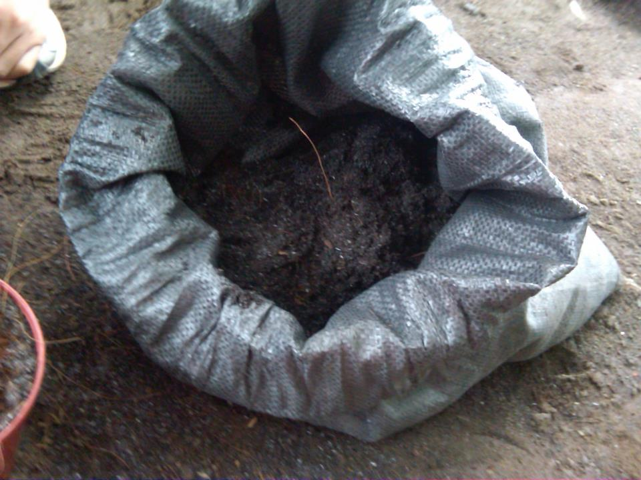

The researchers used mixed soil for the corn plants.

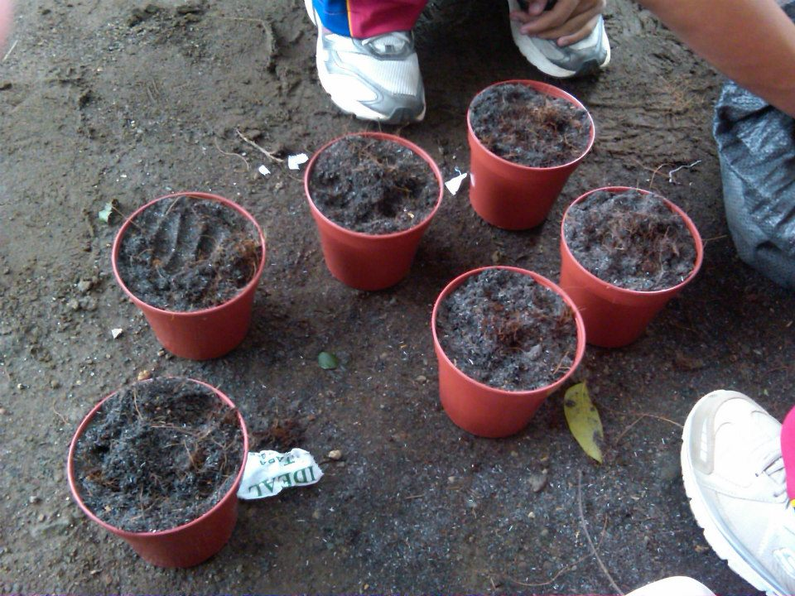

The 3 set ups used by the researchers labeled as Set A: Tap, Set B: Chlorinated and Set C: Chlorinated.

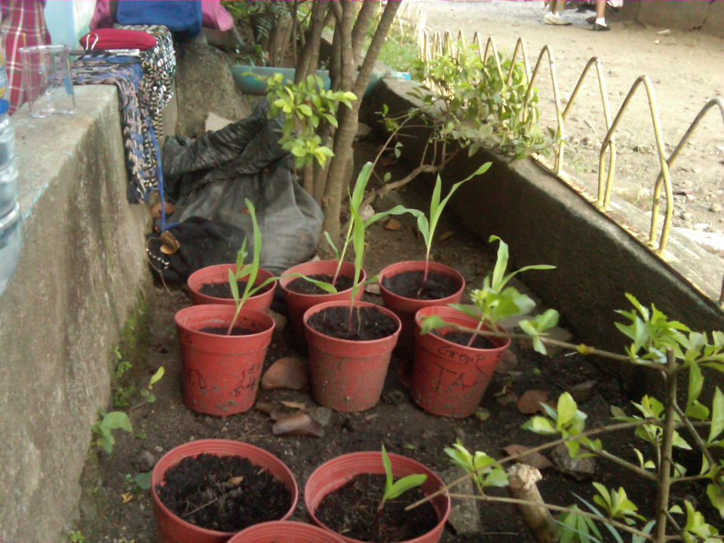

The growth development of the corn plants after a few weeks.