Ramon V. del Rosario Sr. Graduate School of Business

Management and Organization Department



In Partial Fulfilment of the

Course Requirements In

**Operations Management (MSC 525M / GMA)**

**INNOVATIVE PRODUCT DESIGN**

**(SELF DISSOLVING COFFEE TABLET)**

Submitted to:

**Prof. Tristan Macapanpan**

Submitted by:

**Bucsit, Catherine C.**

**Mercaldo, Monina M.**

**Ronquillo, Raymond Jan L.**

**Saguid, Maria Rosarion**

24 February 2014

**TABLE OF CONTENTS**

**PAGE**

1. INTRODUCTION 4
2. TECHNICAL BACKGROUND 5

Coffee Consumption 6

Production Process 6

From Bean to Cup 7

1. PROJECT PROPOSAL / PRODUCT BRIEF 15

Project Proposal 15

Opportunities 16

Scope 16

Assumptions / Constraints 18

Resources 18

1. MARKETING PLAN 19

Marketing Objectives 19

Target Market 19

Market Segmentation 19

Positioning 20

Strategies and Marketing Program 20

Market Research 20

Advertising and Promotion 21

Structure and Function of Sales Department 23

Compensation Scheme for the Employees 24

1. THE DESIGN PROCESS TO BE USED 24

Idea Generation 24

Idea Screening 24

Concept Development and Testing 25

Business Analysis and Market Strategy 25

Feasibility Analysis / Study 25

Product Design and Development 26

Test Market 26

Market Entry 26

1. APPLICATION OF OPERATIONS MANAGEMENT PRINCIPLES 27

Concurrent Engineering 27

Project Management 28

Aggregate Planning / MRP 29

Inventory Management and Supply Chain Management 31

Production Management 34

Operations Scheduling 37

Facilities Layout and Location 39

Quality and Reliability 41

Bibliography 46

**I. INTRODUCTION**

The essence of a business corporation is the products and services it offers, and every aspect of the organization and its supply chain are structured around those products and services. Organizations that have well designed products or services are more likely to realize their goals than those with poorly designed products or services. Hence, organizations have a strategic interest in product and service design. Product or service design should be closely tied to an organization’s strategy. It is a major factor in cost, quality, time-to-market, customer satisfaction, and competitive advantage. The introduction of new products or services, or changes to product or services design can have impacts throughout the organization as well as the entire supply chain. (Stevenson, 2010)

**Product** is a good, service, or idea consisting of a bundle of tangible and intangible attributes that satisfies consumers and is received in exchange for money or some other unit of value. (Richea, 2012)

**Product design** is the process of creating a new product to be sold by a business to its customers. A very broad concept, it is essentially the efficient and effective generation and development of ideas through a process that leads to new products. It is a systematic decision making related to all aspects of the development and management of the products.

In a systematic approach, product designers conceptualize and [evaluate](http://en.wikipedia.org/wiki/Evaluate) ideas, turning them into tangible inventions and products. The product designer's role is to combine art, science, and technology to create new products that other people can use. In the design process, ideas, consumer needs and wants are transformed into a product that will satisfy these needs.

Product development are created as a result of an idea or perceived gap in the current world. It usually arises from a need or want that can’t be immediately filled and leads to the question “Why don’t I create and sell that product?” The market doesn’t have a product that exists that will satisfy those needs.

In order for a new product idea to succeed, it must be or have:

- Desirable attributes for their target market

- Be unique

- If the new product isn’t, it is doomed to fail

**II. TECHNICAL BACKGROUND**

Coffee is a brewed beverage prepared from the roasted seeds of several species of an evergreen shrub of the genus Coffea. Coffee plants are cultivated in more than 70 countries, primarily in equatorial Latin America, Southeast Asia, and Africa.

Despite the different flavors and varieties, there are really only two types of coffee. Arabica is the more common type of bean grown (70 percent of coffee is Arabica), and it is considered more flavorful. Robusta is hardier, cheaper, and has more bitter taste.

Coffee is an essential commodity and a popular beverage nowadays. Over 2.25 billion cups of coffee a day is consumed in the world every day. After crude oil, coffee is the most sought commodity in the world. Coffee is worth over $100 billion worldwide. That puts it ahead of commodities like natural gas, gold, sugar and oil.

Coffee is slightly acidic (ph 5.0-5.1) and can have a stimulating effect on human due to its caffeine content. It is one of the most-consumed beverages in the world. It can be prepared and presented in a variety of ways. The effect of coffee on human health has been a subject of many studies, however, results have varied in terms of coffee’s relative benefits. The majority of research suggests that moderate coffee consumption is benign or mildly beneficial in healthy adults. (Coffee, 2014)

**COFFEE CONSUMPTION**

The United States is currently the world’s largest market for coffee. Annual consumption per capita is just over 4kg compared with 5kg on average in Europe.

Consumption in Europe varies from around 10kg per capita per year in the Nordic countries (Denmark, Finland, Iceland, Norway and Sweden) to around 3kg in the United Kingdom and the most of Eastern Europe.

The annual consumption of over 5kg per capita in Brazil is exceptionally high among the over 60 coffee-producing countries. Brazil’s annual production of around 2.4 million tonnes (40 million 60-kg bags) makes up a third of the world production of just over 7 million tonnes.

Territory size shows the proportion of all coffee worldwide that is consumed in the territory.

**PRODUCTION**

Coffee is a brewed beverage with a strong flavor prepared from the roasted seeds of beans are found in coffee “cherries”, which grow on trees cultivated in over 70 countries, primarily in equatorial Latin America, Southeast Asia, South Asia and Africa. Green (unroasted) coffee is one of the most traded agricultural commodities in the world. (Statistics Brain, 2014)

The production and export of coffee was once a major industry in the Philippines, which 200 years ago was the fourth largest coffee producing nation. Today, however, the Philippines produces only 0.12% of the world’s coffee supply. Efforts are being undertaken to revive the industry however, with the majority of coffee produced in the mountain areas of Batangas, Bukidnon, Benguet, Cavite, Kalinga Apayao, Davao, and Claveria.

(Wikipedia, 2014)

The government and the private sector are both making efforts to increase local coffee production, in order to reduce the reliance on imports. In 2012, however, local production in the Philippines still did not meet coffee demand in the country. The country imports the rest of its coffee requirements from Vietnam, Indonesia and other Asian countries.

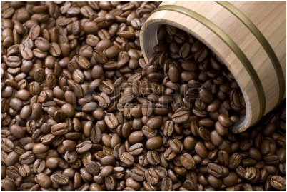

**FROM BEAN TO CUP**

Coffee grows in tropical and subtropical climates - usually no more than 1,000 miles from the equator, and will grow at altitudes between sea level and 7,000 feet. Coffee trees begin their lives in nurseries and stay there until they reach 18 to 24 inches tall, typically after 1 year. They are then transported to a farm and planted 10 to 12 feet apart. Coffee can grow to be 20 feet tall, but due to the difficulty in harvesting, coffee is usually pruned to grow 8-10 feet tall (depending on the country.) It takes 4-5 years for a coffee tree to start producing coffee. Flowers cover the branches of the coffee tree for 2-3 days and release a scent similar to jasmine. Six to nine months later small green cherries that hold two coffee seeds appear. During the ripening process, the coffee cherries evolve from green to yellow, then, at their peak of ripeness, to deep red. A few species turn dark orange/yellow when they are ripe. These berries are referred to as *coffee cherries* because of the resemblance of their color, shape, and size to cherries.The ripe red coffee cherries have several layers. Within the tough outside layer there is a fleshy pulp surrounding a layer of protective parchment and silverskin that encloses two round or oval seeds or 'beans' that are flat on one side. The beans can be planted to grow more coffee or processed to produce green coffee beans that will later be roasted and ground to make fresh coffee.

### Harvesting



* Most of the world's coffee is grown by small farmers on five to seven acres of land. The farmers and their families harvest it by hand into large baskets or sacks when the cherries are ripe. In some coffee farming communities, the coffee harvest is a rotating project where the entire community shares in the activity and moves from farm to farm as the crop ripens. The saying goes, "today for me, tomorrow for you." In countries like Brazil, where the land is flat and larger farms dominate the landscape, mechanical harvesters are commonly used to pick the crop. All Equal Exchange coffees are harvested by hand. This is a tremendous amount of work! Coffee cherries ripen at different times depending on the farm, the tree and the climate. It may require three to seven pickings to complete the harvest.
* Coffee ripens throughout the harvest season, but is divided into the beginning, middle and end of the harvest. Generally, the lower the altitude, the warmer the climate and the sooner the crop will ripen. In other words, coffee at 1,800 feet will ripen faster then coffee grown at 3,000 feet. The beginning of the harvest yields a smaller amount of coffee and the flavor is oftentimes thought to be astringent, vegetal, and undeveloped in flavor. The middle of the harvest brings in the bulk of the crop, with a more developed and mature flavor. The end of the harvest is usually seen as the leftovers from the season. At Equal Exchange, we buy our coffee in the middle of the harvest when the coffee is more refined and mature in flavor and there is more coffee to choose from to match our specific flavor profiles.

**Depulping**

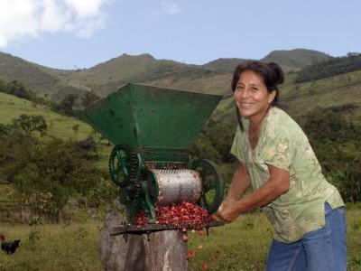

* After coffee cherries are picked, they must be depulped within 24 hours - either at the farm or a centralized depulping station. Depulping is the process of separating the coffee seeds from the outer layer of flesh. If the cherries pass the 24-hour mark without being depulped, they may produce an overly fruity, rotten flavor that can ruin the quality of the coffee.
* Hand Depulpers: Many producers have hand depulpers on their farms or share a hand depulper with their neighbors. A hand depulper is a machine with a small rotating burr that tears off the outer layer of the coffee flesh, exposing the two coffee seeds inside. Some producers operate their depulpers by hand and others have mechanized them to help with the labor. The depulper deposits the coffee seeds into a tank and the remaining skin and flesh is separated and commonly used for compost.
* Centralized Depulping Stations: Anywhere from 10 to 100 farmers may share a centralized station, depending on the size of the depulper and the makeup of their organization. The depulper station is usually run by electricity or some kind of sustainable energy source. As is the case with hand depulpers, the outer layer of the cherry is removed and separated from the beans that are deposited into a tank to begin the process of fermentation.

### Fermenting

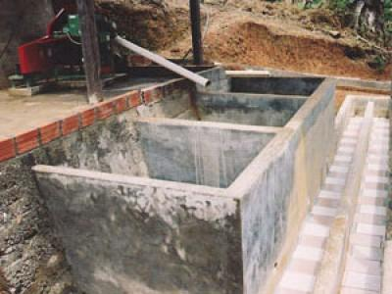

* The fermentation process is thought to accentuate the body and flavor of the coffee beans. To begin the fermentation process, the depulped coffee beans are deposited into large, clean tanks that are made of cement, wood and sometimes plastic water collection receptacles. The coffee beans ferment in the mucilage that is left on the bean after the depulping process, transforming the natural sugars to liquid. Fermentation can take from four hours to three days depending on the country, altitude and humidity of a particular area. It is especially important that the tanks are cleaned out after each use to avoid bacterial build up which can affect the flavor of the next batch of fermenting coffee. One common method used to determine if the fermentation process is complete is to submerge a clean stick into the fermentation tank, then pull it out. If the circle created by the stick remains, the sugars have not dissolved enough, and the coffee is not ready to be washed to end the fermentation process. If the coffee beans easily flow back together, fermentation is complete and the beans are ready to be washed.

**Drying**

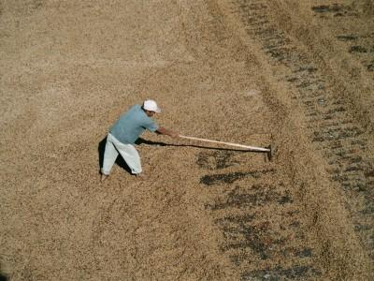

* Many specialty coffees are washed once the fermentation is complete to halt the fermentation process. This is called "wet processing," where coffee beans are washed in a series of concrete or wood channels with clean water. This process ensures that the fermentation process has stopped. The coffee is then dried, either by the sun or mechanically. The process for sun drying coffee can take three to five days or almost two weeks, depending on the weather. It is very important that the drying coffee is turned many times each day and does not come into contact with any water after the washing process is complete and the drying process is underway. All of the coffee that we buy at Equal Exchange is dried by the sun on concrete patios or on raised screens. When the coffee has been dried down to 12% moisture and a thin shell, called parchment, encapsulates each coffee bean, the producers pull the coffee off of the patios or screen trays, put it into coffee sacks, and divide it in their warehouses to prepare for export.
* **Dry Processing vs. Wet Processing**

Coffee is processed in many different ways throughout the world. In some cases, coffee cherries are not depulped, but harvested when ripe and laid out to dry. Or, the coffee cherries may be left to partially dry on the tree, then picked and placed on patio to dry in the sun. In both methods, the cherries are left to dry in the sun for two to three weeks and then put through a hulling machine to remove the dried pulp, parchment and silverskin. This type of processing, called "dry processing," is believed to produce a heavy-bodied cup of coffee. Within the coffee industry, these beans are usually referred to as *naturals*.

### Sorting

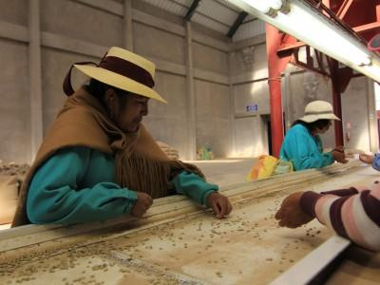

* There are three ways to sort coffee beans for defects:
* By Hand: Coffee is sorted by hand removing all of the defects at individual and group tables.
* By Hand With Conveyor Assistance: A conveyor belt slowly moves coffee down a line of people, usually women, and they pick out the imperfect beans and remove them from the conveyor belt.
* By Machine: A mechanized system moves the beans through a chute at a controlled rate, while a "mechanical eye," programmed to sort beans by color, blows a puff of air to remove discolored, defective beans from the line of production.
* Most of the coffee from Equal Exchange's producer partners is sorted by hand.

### Roasting

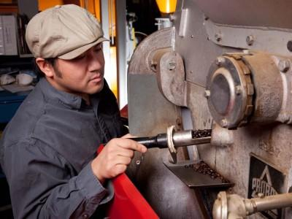

* Roasting requires a skill set somewhere between art and science. Roasters need to have a strong attention to detail, excellent sensory skills and sensory memory, and a love of all things coffee. These traits differentiate between good roasters and great ones. The goal in coffee roasting is to enhance the qualities of the green coffee beans and to develop them to their fullest potential. For example, we might try to tame a coffee's acidity while accentuating its citric flavor, or we might try to bring out the mouthfeel in a coffee while also enhancing its natural **chocolate** notes. As our roasters will tell you, the process is both challenging and extremely rewarding. Each batch of roasted coffee is tested with an Agtron roast analyzer to scientifically test the classification of the roast. The Agtron system is common in the Specialty Coffee Industry and the rating system is from 0.0 points (darkest) to 100 points (lightest). These samples are also "cupped" to ensure that the flavor matches our specifications and to provide our customers with consistency.
* **Roast Levels**

**Medium Roast:** As coffee beans begin to develop, they reach the first stage of roasting that is light in color and bright in the cup. (*Color*: Cinnamon Brown)

**Full City Roast:** The most desirable characteristics of a particular country or region are exemplified in our full city roast. Beans are at their most complex and most flavorful. (*Color*: Chestnut Brown)

**Vienna Roast**: Rich coffee oils evenly cover the surface of the beans to produce a smokey aroma and smooth, rich cup. (*Color*: Dark Chocolate Brown)

* **French Roast:** The intensity of this dark roast is seen in the deep coffee oils that cover its surface. The sweet intensity of the aroma and velvety flavor make this an international favorite. (*Color*: Mahogany Brown)
* **Blending**

We employ two methods of blending called pre-roast blending and post-roast blending. The concepts are different, and each produces an array of flavor combinations that are unique to the palette and are a fresh experience for the coffee lover. Pre-Roast blending: Green origin coffees are selected to create an exclusive profile and then blended before they are roasted. Post-Roast blending: Two or more green coffees are roasted individually and blended after they have been roasted. The color difference between the roasts is distinct, and this method creates an exceptional flavor profile.

### Quality Analysis

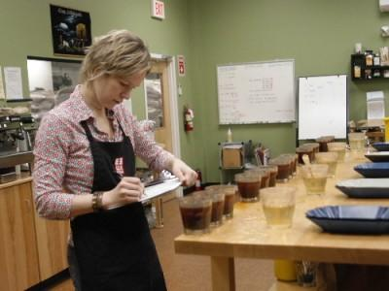

* Our farmer partners take representative samples from each lot of coffee in their warehouse set for export. The samples are milled to remove the parchment, then sent to Equal Exchange for approval. Each green coffee sample sent to Equal Exchange is put through a strict physical quality examination of the size, the color, the smell, the density, the number of imperfections and the amount of moisture in the green coffee beans. If the sample does not fall within our adopted quality standards - those set by the Specialty Coffee Association of America (SCAA) - the lot of coffee will be rejected.
* Each sample is then roasted to a cinnamon color in our double barrel Probat sample roaster. This style of roasting is required for tasting the sample through "cupping." We use the internationally recognized cupping form of the SCAA which is based upon a 100 point system with 10 categories. This is similar to the system used for scoring wine, and highlights the outstanding characteristics that make coffee so special. The objective of cupping is to pull out the fine characteristics of a particular coffee through this lighter roast and to test the power and consistency of the sample. All coffee samples are *cupped* blindly to avoid bias.
* Quality Feedback for our Farmer Partners
* Each year, our buying team makes numerous trips to visit our farmer partners and to investigate coffee crops. In the process of selecting coffees, we work with our producer partners to deepen the relationships and share in the evolution of a common vocabulary. We share important information about the U.S. market, and the farmers, in turn, share their experiences with us. For each sample of green beans that we analyze, roast and cup, we send a report back to our producer partners. This is vital information for our producer partners and enables them to make changes, adjustments and improvements over time. The physical record of a particular imperfection, the way a coffee is roasted and the notes about a particularly unique characteristic in the cup are useful, and deepen the bond between buyer and producer. Most coffee companies do not provide specific feedback to producers, instead they get a simple rejection of the coffee. (Equal Exchange)

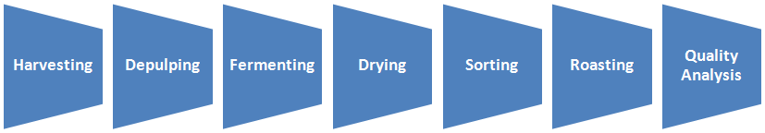 **The Coffee Production Process**

**III. PROJECT PROPOSAL / PRODUCT BRIEF**

**Project Background**

Recently, there has been an increasing trend toward the use of instant coffee in place of ground coffee beans. Although there are advantages of convenience and time saving in terms of using instant coffee over the round whole coffee beans, there are at the same time inherent disadvantages in using instant coffee we usually consume nowadays.

Usually, it is being sold as a loose powder in rigid containers or sachets in various size from which the appropriate quantity is being measured by teaspoon, or the like which oftentimes result in inaccuracy in measuring out the powder, thus there is a wide fluctuation in the strength of coffee and even result in mess through spillage.



**Opportunities**

There pose an opportunity to develop an innovative coffee product which addresses a real consumer need and creates value in the following:

- Increase convenience for consumers: product that gives the consumer the opportunity to save time

- Less packaging material use which contributes to positive environmental impact

- Captures a greater share of health conscious consumer

- Trading up: something people would pay a little more vs their usual product in exchange with perceived benefits

**Scope**

This product proposal aims to overcome disadvantages by producing an instant coffee in convenient tablet format of uniform size, to be added in hot water and doesn’t need stirring or will even rapidly dissolve with mild stirring due to its self dissolving properties. This will be made possible by preparing the coffee tablet from a homogenous mixture of powdered instant coffee, small amount of wetting agent, will serve also as a binder, and a disintegrating combination of sodium bicarbonate and alginic acid, an organic and tasteless which will create the self dissolving properties of the tablet. There will be two type - with caffeine and decaffeinated with Chamomile extract for calming effect.

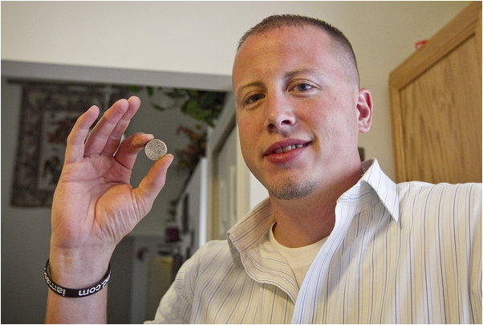

It will be individually packaged using a sustainable pack material structure to maintain its strength and aroma.

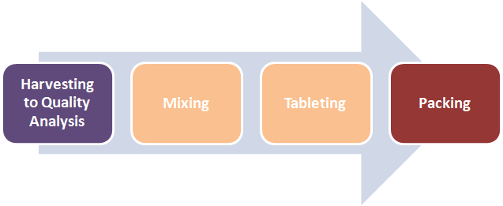

**The process of making coffee tablet**

**Assumptions / Constraints**

The product will be branded under Nescafe brand since they dominate sales with a value share nearly 90%, due to strong positioning and market leadership in instant coffee sector. The company’s Nescafe brand was one of the first instant coffee brands in the country and hence was able to establish a large and loyal consumer base through effective advertising, conscious innovation and the good quality of its coffee products. its programmes to help develop the domestic coffee industry also gives the company a competitive edge. In fact in 2012, Nestle Philippines Inc, opened a new coffee center in Batangas City that will increase access to coffee farming techniques in a bid to increase the number of coffee producers and production in the country.

However, the more widespread health and wellness trend encourage brand manufacturers to produce organic or decaffeinated coffee variants to prevent decline in the consumer base. (Euromonitor, 2013)

**Resources**

The usual process of coffee production will be used however, after roasting, an additional process of mixing (for homogenous mixing coffee powder, wetting agent, binder) will be used, then to be transferred in a pressing machine for forming of the coffee tablet before packing.

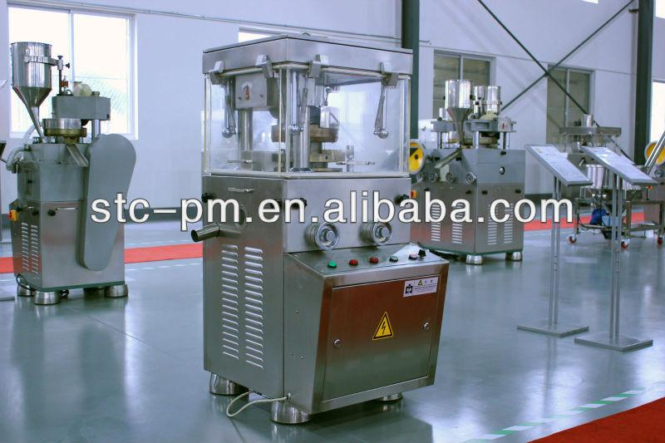

**IV. MARKETING PLAN**

### Marketing Objectives

· Maintain or increase 90% market share leadership

· Achieve positive, strong growth in sales

### Target Market

The target market of Nescafe coffee tablet are coffee drinkers with specific need for quick solution to quality coffee. The company will retain their existing consumer-base of their instant coffee but offering a new way to enjoy the inherent quality of their coffee. With the new coffee tablet, people can enjoy their coffee at the comfort of their home at their own convenience, or basically everywhere, in no time.

### Market Segmentation

Considering the large market size, Nescafe will continue to focus in catering the current market segmentation of instant coffee drinkers. This includes middle-aged to elderly people, from lower, middle, and upper class. Working professionals who work on fast-paced environment are of special focus as the primary advantage of coffee tablet is portability, convenience, and ease of use.

### Positioning

Nescafe will position its coffee tablet together with the existing instant coffee products. It will use its competitive advantage as the most experienced and knowledgeable in the instant coffee industry to be the best company to offer instant coffee products.

## Strategies and Marketing Programs

## MARKET RESEARCH

### Update Customer Data Base

The peak season is the best time to collect data from the customers (collect names, addresses, etc.) Interactions with the customers serve as an opportunity maintain and improve customer relationship.

### Competitors’ Activities and Buying Patterns

The huge market potential of the coffee industry can be very enticing to enter; therefore, Nescafe should always be on top of their game monitoring the latest trends and competitors activities.

Furthermore, monitoring buying patterns can be a tool to predict on when, where, what channels should have an increase or decrease in inventory.

Another important aspect of market research knows what the customers really want. Customer trends can help the manufacturing side to add value to existing products or to freshen up the product mix.

**Advertising and Promotion**

TV/ Print Advertising All Year Long



Nescafe will continue to use T.V. and Printed Advertisements to reach out to consumers. A typical advertisement will feature the product packaging, process of preparing the instant coffee (coffee tablet), and consumers sitting down, enjoying their cups of coffee after a minimum time of preparation. Images and clips will also be show to emphasize on the high quality and aroma of the coffee.

### Social Media and Networking Sites



Nescafe will continue to use social media tools not only to inform consumers but also to involve them in creating and understanding the new product. Social media is a great tool to capitalize on because it establishes direct connection between the brand (and product), and the consumers.

### Facebook



As of 24 February 2014, Nescafe Philippines has accumulated 15,228,767 likes with around 280,142 people talking about it. To engage fans and followers, Nescafe posts several contents on its Facebook page such as fun facts, quotes, and images that will surely have “likers” (fans) craving for coffee. Nescafe also posts promotional contests where fans can win prizes.

### Twitter



Nescafe also uses Twitter to reach to their consumers on the go. Their Twitter and Facebook accounts are synchronized and contents posted are similar. As of 24 February 2014, Nescafe Philippines has 3,313 followers and 2,115 tweets.

### YouTube



Nescafe uses YouTube to post its promotional videos such as management interviews and product television advertisements for the enjoyment of the consumers. As of 24 February 2014, Nescafe Philippines YouTube account has 3,258 subscribers and several video postings of all Nescafe products.

### Structure and Function of the Sales Department

The sales team will be given specific territories and targets that they need to meet annually to maintain market share leadership and steady growth.

**1. Product Specialists**

The product specialist will focus only in promoting the coffee tablet and will emphasize on the advantages of the new product innovation over the other instant coffee products of the company.

**2. After Sales Service Personnel**

After sales evaluation, it is important to maintain good relationships with the customers. The main function of the after sales department is to monitor buying patterns of the consumers, and monitor feedbacks via supermarkets, grocery stores, retailers, and the customers themselves.

**3. Direct Selling Agents**

They are the first line of the sales force that will approach consumers, supermarkets, and retailers to carry the new Nescafe coffee product. They will also hand out brochures to inform consumers of the new product.

### Compensation Scheme for the Employees

Creating a better compensation package for the Sales Personnel will keep them motivated in achieving their target. In return, the company’s market share leadership will be retained and steady sales growth will be achieved.

**V. THE DESIGN PROCESS TO BE USED**

**1. Idea Generation**

Ideas for this product can be obtained from basic research using SWOT analysis, market and consumer trends, competitors, focus groups, employees, salespeople, corporate spies, tradeshows, or ethnographic discovery methods (searching for user patterns and habits may also be used to get an insight into new product lines or product features.

Lots of ideas are generated about the new product. Out of these ideas many are implemented. This should answer the question “What ideas do we have and what new products do we think could be successful?”

**2. Idea Screening**

Not all ideas are good ones, thus marketers need to test consumer reaction to idea before they continue, throw the idea around and see what people think, get their feedback and make modifications and assess whether or not it’s a good idea. The objective is to eliminate unsound concept prior to devoting resources to them. This should answer several questions such as: “Will the customer in the target market benefit from the product?” “What is the size and growth forecasts of the market segment/target market?” “What is the current or expected competitive pressure for the product idea?” ‘What are the industry sales and market trends the product idea is based on?” Is it technically feasible to manufacture the product?”

**3. Concept Development and Testing**

This stage will allow to see if the product works and to allow the target market to use it/provide feedback for improvements, etc. This is when the concept will be tested by asking number of prospective customers will be asked or interviewed on what they think of the idea. This stage will allow to see the actual product and how it works. if the feedback from consumers and business associates is positive, a prototype or sample is created. It will allow to see if the market demand exists and that competition will not prevent us from being successful.

**4. Business Analysis /Market Strategy**

The development of marketing strategy. Target market is determined and how to use the 4P’s to optimally sell them the product and actually ensure that the product addresses the target market needs as well as identifying the primary target market to ensure that these consumers will be reached.

**5. Feasibility Analysis / Study**

This stage should simply answer the question “Can we make and sell this product and make money doing it?” This should answer the material and labor required to product the product, is the price production can be way too high, are there distribution channels in place to get the product to the consumer, and the cost effective methods in promoting the product. In this stage, several testings are done such as machine or line trial, transit test, stability test to ensure feasibility of the product.

**6. Product Design and Development**

What the product will look like, the design will depends on what it does and what the target market want. This is when prototyping is done and cost calculation is finalized. Product and packaging specifications are also finalized here. This is also the time when risk assessment and action plan is initiated.

**7. Test Market**

This is the time when test acceptance of the product occurs. This is usually done by offering the product to a random sample of the target market. This includes testing the product in typical usage situations by conducting focus group consumer interviews. Consumer feedback is used to improve the venture and determine whether the product should go to market and get customer acceptance.

**8. Market Entry**

The product is officially in the market and being sold to all. This is when the launching of the product takes place and fill the distribution pipeline with product. The product Life Cycle begins and it’s life will be determined by the consumer market, competition and further product advances. Post launch evaluation and review is also done to check product performance in the market.

Following this process provides a new product with a much better chance of success. The process should be constantly revisited and should be improved and updated to stay ahead of competitors. (Wikipedia, 2014)

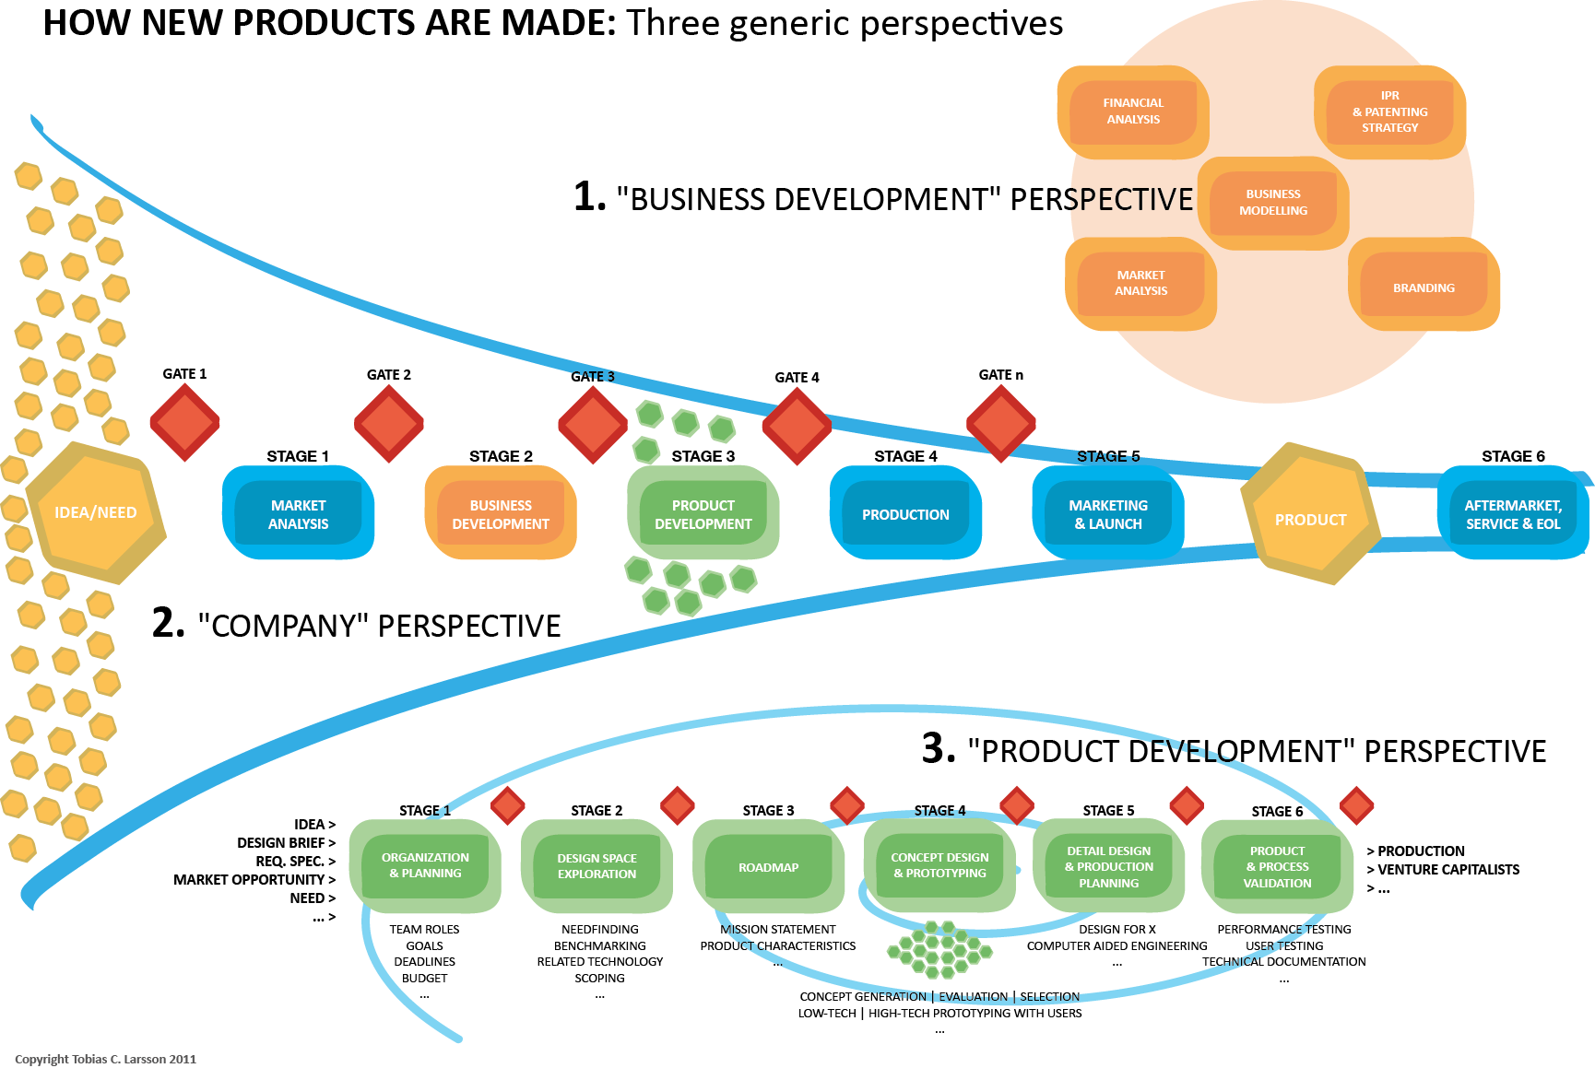

**The Design Process**

**VI. APPLICATION OF OPERATIONS MANAGEMENT PRINCIPLES**

The following critical factors should be considered to ensure its manufacturability and success in operation.

**CONCURRENT ENGINEERING**

This gives emphasis on the integration of cross functional teams to develop the product. The use of teams, including all the stakeholders, eliminates many of the problems and their involvement even in the early stage of the process is very important.



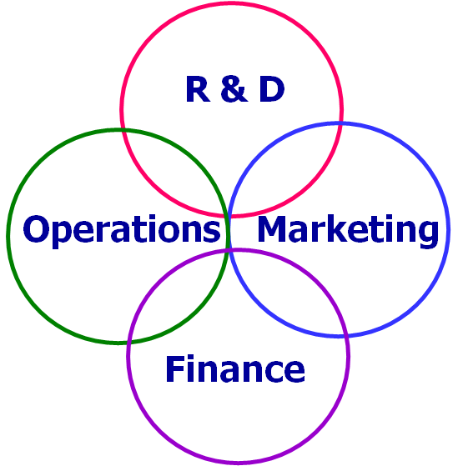

**PROJECT MANAGEMENT**

This is important in planning and managing the organization’s resources in order to move the tasks, event, or duty toward completion. The project team will define the goals and objectives of the project and determine when the various project components are to be completed and by whom, and create quality control checks to ensure that completed components meet a certain standard. Visual representations of workflow, such as Gantt chart, PERT chart, Microsoft Project, etc. can be used to determine which tasks are to be completed by whom.

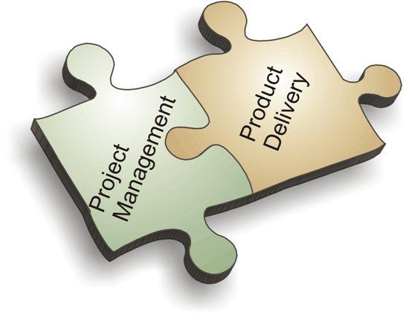

**Aggregate Planning / Materials Requirements Planning (MRP)**

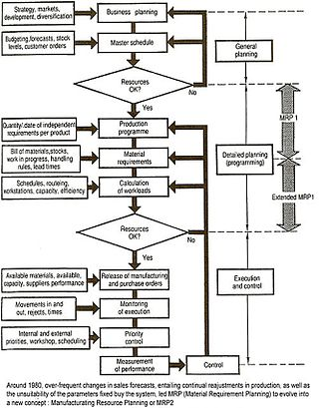

## The scope of MRP in manufacturing

The basic functions of an MRP system include: inventory control, bill of material processing, and elementary scheduling. MRP helps organizations to maintain low inventory levels. It is used to plan manufacturing, purchasing and delivering activities.

"Manufacturing organizations, whatever their products, face the same daily practical problem - that customers want products to be available in a shorter time than it takes to make them. This means that some level of planning is required."

Companies need to control the types and quantities of materials they purchase, plan which products are to be produced and in what quantities and ensure that they are able to meet current and future customer demand, all at the lowest possible cost. Making a bad decision in any of these areas will make the company lose money. A few examples are given below:

* If a company purchases insufficient quantities of an item used in manufacturing (or the wrong item) it may be unable to meet contract obligations to supply products on time.
* If a company purchases excessive quantities of an item, money is wasted - the excess quantity ties up cash while it remains as stock and may never even be used at all.
* Beginning production of an order at the wrong time can cause customer deadlines to be missed.

MRP is a tool to deal with these problems. It provides answers for several questions:

* *What* items are required?
* *How many* are required?
* *When* are they required?...

MRP can be applied both to items that are purchased from outside suppliers and to sub-assemblies, produced internally, that are components of more complex items.

The data that must be considered include:

* The *end item* (or items) being created. This is sometimes called Independent Demand, or Level "0" on BOM (Bill of materials).
* How much is required at a time.
* When the quantities are required to meet demand.
* Shelf life of stored materials.
* Inventory status records. Records of *net* materials *available* for use already in stock (on hand) and materials on order from suppliers.
* Bills of materials. Details of the materials, components and sub-assemblies required to make each product.
* Planning Data. This includes all the restraints and directions to produce the end items. This includes such items as: Routing, Labor and Machine Standards, Quality and Testing Standards, Pull/Work Cell and Push commands, Lot sizing techniques (i.e. Fixed Lot Size, Lot-For-Lot, Economic Order Quantity), Scrap Percentages, and other inputs. (Wikipedia, 2014)

**Inventory Management and Supply Chain Management**

**Supply chain management** (**SCM**) is the management of the flow of goods. It includes the movement and storage of raw materials, work-in-process inventory, and finished goods from point of origin to point of consumption. Interconnected or interlinked networks, channels and node businesses are involved in the provision of products and services required by end customers in a supply chain. Supply chain management has been defined as the "design, planning, execution, control, and monitoring of supply chain activities with the objective of creating net value, building a competitive infrastructure, leveraging worldwide logistics, synchronizing supply with demand and measuring performance globally."

SCM draws heavily from the areas of operations management, logistics, procurement, and information technology, and strives for an integrated approach.

## Problems addressed

Supply chain management addresses the following problems:

* **Distribution network configuration**: the number, location, and network missions of suppliers, production facilities, distribution centers, warehouses, cross-docks, and customers.
* **Distribution strategy**: questions of operating control (e.g., centralized, decentralized, or shared); delivery scheme (e.g., direct shipment, pool point shipping, cross docking, direct store delivery, or closed loop shipping); mode of transportation (e.g., motor carrier, including truckload, less than truckload (LTL), parcel, railroad, intermodal transport, including trailer on flatcar (TOFC) and container on flatcar (COFC), ocean freight, airfreight); replenishment strategy (e.g., pull, push, or hybrid); and transportation control (e.g., owner operated, private carrier, common carrier, contract carrier, or third-party logistics (3PL)).
* **Trade-offs in logistical activities**: The above activities must be coordinated in order to achieve the lowest total logistics cost. Trade-offs may increase the total cost if only one of the activities is optimized. For example, full truckload (FTL) rates are more economical on a cost-per-pallet basis than are LTL shipments. If, however, a full truckload of a product is ordered to reduce transportation costs, there will be an increase in inventory holding costs, which may increase total logistics costs. The planning of logistical activities therefore takes a systems approach. These trade-offs are key to developing the most efficient and effective logistics and SCM strategy.
* **Information**: The integration of processes through the supply chain in order to share valuable information, including demand signals, forecasts, inventory, transportation, and potential collaboration.
* **Inventory management**: Management of the quantity and location of inventory, including raw materials, work in process (WIP), and finished goods.
* **Cash flow**: Arranging the payment terms and methodologies for exchanging funds across entities within the supply chain.

Supply chain execution means managing and coordinating the movement of materials, information and funds across the supply chain. The flow is bi-directional. SCM applications provide real-time analytical systems that manage the flow of products and information throughout the supply chain network.

## Functions

**Supply chain management** is a cross-functional approach that includes managing the movement of raw materials into an organization, certain aspects of the internal processing of materials into finished goods, and the movement of finished goods out of the organization and toward the end consumer. As organizations strive to focus on core competencies and becoming more flexible, they reduce their ownership of raw materials sources and distribution channels. These functions are increasingly being outsourced to other firms that can perform the activities better or more cost effectively. The effect is to increase the number of organizations involved in satisfying customer demand, while reducing managerial control of daily logistics operations. Less control and more supply chain partners led to the creation of the concept of supply chain management. The purpose of supply chain management is to improve trust and collaboration among supply chain partners, thus improving inventory visibility and the velocity of inventory movement. (Wikipedia, 2014)

**Inventory Control** is the supervision of supply, storage and accessibility of items in order to ensure an adequate supply without excessive oversupply.

It can also be referred as internal control - an accounting procedure or system designed to promote efficiency or assure the implementation of a policy or safeguard assets or avoid fraud and error etc.

**Inventory control** may refer to:

* In economics, the inventory control problem, which aims to reduce overhead cost without hurting sales
* In the field of loss prevention, systems designed to introduce technical barriers to shoplifting

It answers the 3 basic questions of any supply chain: 1. When? 2. Where? 3. How much? (Wikipedia, 2013)

**Production Management**

In Production Management the process of producing products from raw material is managed. The production process itself, as well as monitoring the quality of produced products, the maintenance of the machine used in production and the cost management for raw material and end products in managed.

### Production Management

The main documents to manage the production process are:

* the Process Plan
* the Work Requirement
* the Work Effort

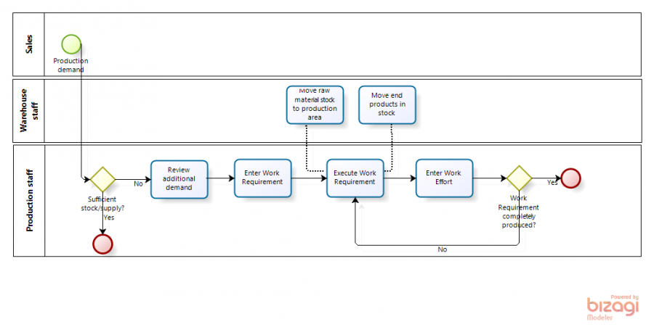

(openbravo, 2012)

Production management means planning, organizing, directing and controlling of production activities.

Production management deals with converting raw materials into finished goods or products. It brings together the 6M's i.e. men, money, machines, materials, methods and markets to satisfy the wants of the people.

Production management also deals with decision-making regarding the quality, quantity, cost, etc., of production. It applies management principles to production.

Production management is a part of business management. It is also called "**Production Function**." Production management is slowly being replaced by operations management.

The main **objective** of production management is to produce goods and services of the right quality, right quantity, at the right time and at minimum cost. It also tries to improve the efficiency. An efficient organization can face competition effectively. Production management ensures full or optimum utilization of available production capacity.

**Importance of Production Management**

The importance of production management to the business firm:

1. **Accomplishment of firm's objectives** : Production management helps the business firm to achieve all its objectives. It produces products, which satisfy the customers' needs and wants. So, the firm will increase its sales. This will help it to achieve its objectives.
2. **Reputation, Goodwill and Image** : Production management helps the firm to satisfy its customers. This increases the firms reputation, goodwill and image. A good image helps the firm to expand and grow.
3. **Helps to introduce new products** : Production management helps to introduce new products in the market. It conducts Research and development (R&D). This helps the firm to develop newer and better quality products. These products are successful in the market because they give full satisfaction to the customers.
4. **Supports other functional areas** : Production management supports other functional areas in an organization, such as marketing, finance, and personnel. The marketing department will find it easier to sell good-quality products, and the finance department will get more funds due to increase in sales. It will also get more loans and share capital for expansion and modernization. The personnel department will be able to manage the human resources effectively due to the better performance of the production department.
5. **Helps to face competition** : Production management helps the firm to face competition in the market. This is because production management produces products of right quantity, right quality, right price and at the right time. These products are delivered to the customers as per their requirements.
6. **Optimum utilization of resources** : Production management facilitates optimum utilization of resources such as manpower, machines, etc. So, the firm can meet its capacity utilization objective. This will bring higher returns to the organization.
7. **Minimizes cost of production** : Production management helps to minimize the cost of production. It tries to maximize the output and minimize the inputs. This helps the firm to achieve its cost reduction and efficiency objective.
8. **Expansion of the firm** : The Production management helps the firm to expand and grow. This is because it tries to improve quality and reduce costs. This helps the firm to earn higher profits. These profits help the firm to expand and grow.

The importance of production management to customers and society:

1. **Higher standard of living** : Production management conducts continuous research and development (R&D). So they produce new and better varieties of products. People use these products and enjoy a higher standard of living.
2. **Generates employment** : Production activities create many different job opportunities in the country, either directly or indirectly. Direct employment is generated in the production area, and indirect employment is generated in the supporting areas such as marketing, finance, customer support, etc.
3. **Improves quality and reduces cost** : Production management improves the quality of the products because of research and development. Because of large-scale production, there are economies of large scale. This brings down the cost of production. So, consumer prices also reduce.
4. **Spread effect** : Because of production, other sectors also expand. Companies making spare parts will expand. The service sector such as banking, transport, communication, insurance, BPO, etc. also expand. This spread effect offers more job opportunities and boosts economy.
5. **Creates utility** : Production creates *Form Utility*. Consumers can get form utility in the shape, size and designs of the product. Production also creates time utility, because goods are available whenever consumers need it.
6. **Boosts economy** : Production management ensures optimum utilization of resources and effective production of goods and services. This leads to speedy economic growth and well-being of the nation. (Kalyan City, 2011)

**Operations Scheduling**

The following concerns should be addressed:

How to sequence production activities on the factory?

Job shop scheduling

2 shifts - 7:00 am to -4:00pm and 9:00 am to -6pm

To meet demand spikes through additional shifts or outsourcing?

Consider the umber of workforce per shift

## OPERATIONS SCHEDULING

Scheduling pertains to establishing both the timing and use of resources within an organization. Under the operations function (both manufacturing and services), scheduling relates to use of equipment and facilities, the scheduling of human activities, and receipt of materials.

While issues relating to facility location and plant and equipment acquisition are considered long term and aggregate planning is considered intermediate term, operations scheduling is considered to be a short-term issue. As such, in the decision-making hierarchy, scheduling is usually the final step in the transformation process before the actual output (e.g., finished goods) is produced. Consequently, scheduling decisions are made within the constraints established by these longer-term decisions. Generally, scheduling objectives deals with tradeoffs among conflicting goals for efficient utilization of labor and equipment, lead time, inventory levels, and processing times.

Byron Finch notes that effective scheduling has recently increased in importance. This increase is due in part to the popularity of lean manufacturing and just-in-time. The resulting drop in inventory levels and subsequent increased replenishment frequency has greatly increased the probability of the occurrence of stock-outs. In addition, the Internet has increased pressure to schedule effectively. "Business to customer" (B2C) and "business to business" (B2B) relationships have drastically reduced the time needed to compare prices, check product availability, make the purchase, etc. Such instantaneous transactions have increased the expectations of customers, thereby, making effective scheduling a key to customer satisfaction. It is noteworthy that there are over 100 software scheduling packages that can perform schedule evaluation, schedule generation, and automated scheduling. However, their results can often be improved through a human scheduler's judgment and experience.

There are two general approaches to scheduling: forward scheduling and backward scheduling. As long as the concepts are applied properly, the choice of methods is not significant. In fact, if process lead times (move, queue and setup times) add to the job lead time and process time is assumed to occur at the end of process time, then forward scheduling and backward scheduling yield the same result. With forward scheduling, the scheduler selects a planned order release date and schedules all activities from this point forward in time.

With backward scheduling, the scheduler begins with a planned receipt date or due date and moves backward in time, according to the required processing times, until he or she reaches the point where the order will be released.

Of course there are other variables to consider other than due dates or shipping dates. Other factors which directly impact the scheduling process include: the types of jobs to be processed and the different resources that can process each, process routings, processing times, setup times, changeover times, resource availability, number of shifts, downtime, and planned maintenance. (Inman)

**Facilities Layout and Location**

Where to locate new facilities?

To be situated in Batangas due to the following reasons:

Cheap labor compared to Metro Manila

Near coffee farms so it is easier to transport raw materials into the factory

What will be the most efficient layout? – This will also be considered

**Product vs process layouts**

**Product layout** is one of the three basic production and manufacturing plant layouts. In this design, the layout of equipment and processes in the workstations are distributed around the needs of the end product. Each station is given a small task to complete in a certain sequence. When this task is completed, the work piece is passed on to the next workstation in the sequence for further assembly.

In a manufacturing assembly line set up, the work pieces in this design travel past the individual workstations on a conveyor. As the individual workstations are passed, the worker at the station completes a small task, such as adding a sticker or tightening a bolt. As these jobs are completed in turn, the completed product begins to form.

The design used in product layout differs from process layout and fixed-position layout in that the assembly line is arranged in a logical order of assembly. In some cases, this simple manufacturing layout is realized as a single manufacturing line with various workstations. The product layout design may be further broken down into smaller module lines which use several processes to complete one group task. For example, an auto manufacturer may have an assembly line module in which the car body is cleaned, primed, and painted in a single area of the plant, rather than being moved to three different workstations.

Product layout arrangements often offer some distinct advantages when compared with other plant layout designs. Using this design, manufacturers have noted increased productivity and reduced labor. In addition, because each section of the layout is specialized to its own function, the workers often become more proficient at their tasks, delivering a better overall product.

The disadvantage of product layout designs lies in the fact that the production process centers around the end product. In a single line design, the manufacturing process can become bottlenecked if one workstation is disabled. While preventative measures can be taken to avoid this problem, unplanned maintenance or training new operators for a station can result in the need to shut down the whole assembly line. Workstations ahead of the line can continue to work but downstream modules are affected by upstream production problems in product layout designs. To circumvent this, some manufacturing layouts use separate lines to further divide the work load, ensuring that one line remains operable in most circumstances. (Palmer, 2014)

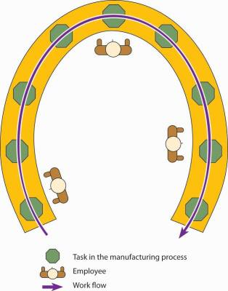

### Key Takeaways

* Managers have several production **layout** choices, including process, product, cellular, and fixed-position.
* The **process layout** groups together workers or departments that perform similar tasks. At each position, workers use specialized equipment to perform a particular step in the production process.
* In a **product layout**, high-volume goods are produced in assembly-line fashion—that is, a series of workstations at which already-made parts are assembled.
* In a **cellular layout**, small teams of workers handle all aspects of building a component, a “family of components,” or even a finished product.
* A **fixed-position layout** is used to make large items (such as ships or buildings) that stay in one place while workers and equipment go to the product.

(Lippman, 2013)

**Quality and Reliability**

Total Quality Management **(TQM)**

Total Quality Management (TQM) is a comprehensive and structured approach to organizational management that seeks to improve the quality of products and services through ongoing refinements in response to continuous feedback. TQM requirements may be defined separately for a particular organization or may be in adherence to established standards, such as the International Organization for Standardization's ISO 9000 series. TQM can be applied to any type of organization; it originated in the manufacturing sector and has since been adapted for use in almost every type of organization imaginable, including schools, highway maintenance, hotel management, and churches. As a current focus of e-business, TQM is based on quality management from the customer's point of view.

TQM processes are divided into four sequential categories: plan, do, check, and act (the *PDCA cycle*). In the *planning* phase, people define the problem to be addressed, collect relevant data, and ascertain the problem's root cause; in the *doing* phase, people develop and implement a solution, and decide upon a measurement to gauge its effectiveness; in the *checking* phase, people confirm the results through before-and-after data comparison; in the *acting* phase, people document their results, inform others about process changes, and make recommendations for the problem to be addressed in the next PDCA cycle.

(Rouse, 2005)

**Control chart design**

## Common Types of Charts

The types of charts are often classified according to the type of quality characteristic that they are supposed to monitor: there are quality control charts for *variables* and control charts for *attributes.* Specifically, the following charts are commonly constructed for controlling variables:

* **X-bar chart.** In this chart, the sample *means* are plotted in order to control the mean value of a variable (e.g., size of piston rings, strength of materials, etc.).
* **R chart.** In this chart, the sample *ranges* are plotted in order to control the variability of a variable.
* **S chart.** In this chart, the sample *standard deviations* are plotted in order to control the variability of a variable.
* **S**2 chart.** In this chart, the sample *variances* are plotted in order to control the variability of a variable.

For controlling quality characteristics that represent *attributes* of the product, the following charts are commonly constructed:

* **C chart.** In this chart (see example below), we plot the *number of defectives* (per batch, per day, per machine, per 100 feet of pipe, etc.). This chart assumes that defects of the quality attribute are *rare*, and the control limits in this chart are computed based on the [*Poisson* distribution](https://www.statsoft.com/textbook/statistics-glossary/p/#Poisson Distribution) (distribution of rare events).

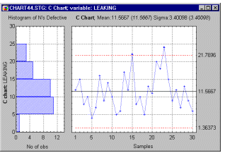

* **U chart.** In this chart we plot the *rate of defectives*, that is, the number of defectives divided by the number of units inspected (the *n*; e.g., feet of pipe, number of batches). Unlike the C chart, this chart does not require a constant number of units, and it can be used, for example, when the batches (samples) are of different sizes.
* **Np chart.** In this chart, we plot the number of defectives (per batch, per day, per machine) as in the C chart. However, the control limits in this chart are not based on the distribution of rare events, but rather on the binomial distribution. Therefore, this chart should be used if the occurrence of defectives is not rare (e.g., they occur in more than 5% of the units inspected). For example, we may use this chart to control the number of units produced with minor flaws.

|  |
| --- |
| * **P chart.** In this chart, we plot the percent of defectives (per batch, per day, per machine, etc.) as in the U chart. However, the control limits in this chart are not based on the distribution of rare events but rather on the binomial distribution (of proportions). Therefore, this chart is most applicable to situations where the occurrence of defectives is not rare (e.g., we expect the percent of defectives to be more than 5% of the total number of units produced).   All of these charts can be adapted for short production runs and for multiple process streams.  (StatSoft, 2014)  **Acceptance sampling**  **Acceptance sampling** uses statistical sampling to determine whether to accept or reject a production lot of material. It has been a common quality control technique used in industry. It is usually done as products leave the factory, or in some cases even within the factory. Most often a producer supplies a consumer a number of items and decision to accept or reject the lot is made by determining the number of defective items in a sample from the lot. The lot is accepted if the number of defects falls below where the acceptance number or otherwise the lot is rejected.  A wide variety of acceptance sampling plans are available. Rationale Sampling provides one rational means of verification that a production lot conforms with the requirements of technical specifications. 100% inspection does not guarantee 100% compliance and is too time consuming and costly. Rather than evaluating all items, a specified sample is taken, inspected or tested, and a decision is made about accepting or rejecting the entire production lot.  Plans have known risks: an acceptable quality limit (AQL) and a rejectable quality level (LTDP) are part of the operating characteristic curve of the sampling plan. These are primarily statistical risks and do not necessarily imply that defective product is intentionally being made or accepted. Plans can have a known average outgoing quality limit (AOQL). Acceptance sampling for attributes A single sampling plan for attributes is a statistical method by which the lot is accepted or rejected on the basis of one sample.[[2]](http://en.wikipedia.org/wiki/Acceptance_sampling#cite_note-2) Suppose that we have a lot of size M; a random sample of size N<Mis selected from the lot; and an acceptance number Bis determined. If it is found the number of nonconforming is less than or equal to B, the lot is accepted; and if the number of nonconforming is greater than B, the lot is not accepted. The design of a single sampling plan requires the selection of the sample size Nand the acceptance number B.  MIL-STD-105 was a United States defense standard that provided procedures and tables for sampling by attributes (pass or fail characteristic). MIL-STD-105E was cancelled in 1995 but is available in related documents such as ANSI/ASQ Z1.4, "Sampling Procedures and Tables for Inspection by Attributes". Several levels of inspection are provided and can be indexed to several AQLs. The sample size is specified and the basis for acceptance or rejection (number of defects) is provided. Variables plans When a measured characteristic produces a number, other sampling plans such as those based on MIL-STD-414 are often used. Compared with attribute sampling plans, these often use a smaller sample size for the same indexed AQL.  (Wikipedia, 2013) |

Bibliography

Wikipedia. (2013, December 21). *Acceptance Sampling*. Retrieved from Wikipedia: http://en.wikipedia.org/wiki/Acceptance_sampling

Wikipedia. (2014, January 8). *Coffee production in the Philippines*. Retrieved from Wikipedia: http://en.wikipedia.org/wiki/Coffee_production_in_the_Philippines

Wikipedia. (2013, May 7). *Inventory Control*. Retrieved from Wikipedia: http://en.wikipedia.org/wiki/Inventory_control

Wikipedia. (2014, February 9). *New product development*. Retrieved from Wikipedia: http://en.wikipedia.org/wiki/New_product_development

Wikipedia. (2014, February 22). *Material requirements planning*. Retrieved from Wikipedia: http://en.wikipedia.org/wiki/Material_requirements_planning

Wikipedia. (2014, February 23). *Supply Chain Management*. Retrieved from Wikipedia: http://en.wikipedia.org/wiki/Supply_chain_management

YouTube. (n.d.). *NescafePH*. Retrieved from YouTube: www.youtube.com/user/NescafePH

*Coffee*. (2014). Retrieved from Wikipedia: http://en.wikipedia.org/wiki/Coffee

Euromonitor. (2013, July). *Coffee in the Philippines*. Retrieved from Euromonitor International: http://www.euromonitor.com/coffee-in-the-philippines/report

Equal Exchange. (n.d.). *From Bean to Cup*. Retrieved from Equal Exchange: http://www.equalexchange.coop/products/coffee/steps

Facebook. (n.d.). *Nescafe Philippines*. Retrieved from Facebook: https://www.facebook.com/nescafe.ph

Inman, R. A. (n.d.). *Operations Scheduling*. Retrieved from Encyclopedia of Business: http://www.referenceforbusiness.com/management/Ob-Or/Operations-Scheduling.html#ixzz2uDriGnIj

Kalyan City. (2011, 12). *What is Production Management?* Retrieved from Kalyan City Life Blog: http://kalyan-city.blogspot.com/2011/12/what-is-production-management-meaning.html

Lippman, D. (2013, September). *Facility Layouts*. Retrieved from lumen: https://lumen.instructure.com/courses/111874 /wiki/facility-layouts?module_item_id=1072021

openbravo. (2012, December 11). *Production Management*. Retrieved from openbravo: http://wiki.openbravo.com/wiki/Production_Management

Palmer, L. R. (2014, February 19). What is a Product Layout? (A. L. Wardle, Ed.) Retrieved from wiseGEEK: http://www.wisegeek.com/what-is-a-product-layout.htm

Statistics Brain. (2014, January 1). *Coffee Drinking Statistics*. Retrieved from Statistics Brain: http://www.statisticbrain.com/coffee-drinking-statistics/

StatSoft. (2014). *What is Quality Control and Quality Control Charts?* Retrieved from StatSoft: https://www.statsoft.com/Textbook/Quality-Control-Charts

Richea, J. (2012, November 14). *Product - Development Stages*. Retrieved February 23, 2014, from YouTube: http://www.youtube.com/watch?v=KWy4UgbzCBU

Rouse, M. (2005, September). *Total Quality Management (TQM)*. Retrieved from SearchCIO: http://searchcio.techtarget.com/definition/Total-Quality-Management

Twitter. (n.d.). *NescafePH*. Retrieved from Twitter: https://www.twitter.com/NescafePH