BIO-INTENSIVE APPROACH TO FOOD PRODUCTION

*By Vilyn Humol, University of the Philippines - Los Banos*

1. INTRODUCTION

The bio-intensive approach is a biological form of agriculture in which a small area of land is intensively cultivated, using nature's own ingredients to rebuild and then maintain the soil's productivity. At the heart of the approach is the effort to improve the soils' capability to nurture and sustain plant life. What a bio-intensive gardener tries to do on his/her small plot is to simulate/replicate a natural forest (with the constant recycling of nutrients and maintenance of soil, moisture and microbial conditions). Many countries of the world have farmed biologically for thousands of years and have been able to sustain output levels over these years.

1. MATERIALS AND METHODS
2. Materials
3. Farm tools
4. Animal manure
5. Crop residue
6. Vegetable seeds
7. Procedure
8. Identification of crops to be planted and cared
9. Preparation of plot
10. Planting of crops according to their plan
11. Care and maintenance of the plot
12. Harvesting of crop products
13. Analysis
14. DATA AND OBSERVATIONS

Table 1.1 Data on planting proper

|  |  |  |
| --- | --- | --- |
| Crop | Planting distance | Seeds planted per hill |
| Kangkong | 15 cm. between hills | 2-3 |
| Mungbean | 3 rows with furrow | 2-3 |
| Okra | 30 cm. between hills | 2-3 |
| Radish | 20 cm. between hills | 2-3 |

Table 1.2 Data on crops’ performance

|  |  |  |  |  |  |  |  |  |
| --- | --- | --- | --- | --- | --- | --- | --- | --- |
| Crop | Number of crop products | | | | Weight of crop products | | | |
| Marketable | | Non-marketable | | Marketable | | Non-marketable | |
| Number | Percent | Number | Percent | Weight | Percent | Weight | Percent |
| Kangkong |  |  |  |  |  |  |  |  |
| Mungbean |  |  |  |  |  |  |  |  |
| Okra |  |  |  |  |  |  |  |  |
| Radish |  |  |  |  |  |  |  |  |

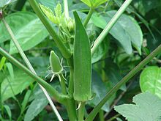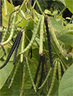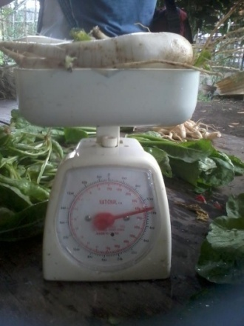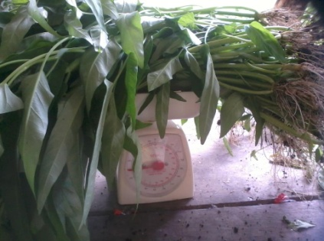

1. RESULTS AND DISCUSSION

In this exercise bio-intensive gardening, which is a form of farming in which a small land area is intensively cultivated using available farm resources, particularly those derived from plants and animals, to enhance and maintain the soil’s productivity, was practiced.

At first, crops to be planted and cared for a certain period of time were identified by the group. These crops are kangkong, mungbean, okra and radish.

Then, plot was prepared in which animal manure and crop residues, particularly the kakawate leaves, were added. Every big-intensive gardener attempts to maximize the use of plant and animal residues and wastes. In an attempt to return to the soil much of what come out from it, material is recycled back to the soil. In the big-intensive approach, organic matter is returned to the soils in the form of compost after each crop. The cultivation of a range of crops (each of different rooting lengths) tends to retain organic residues in the soil at different depths (when plants are pulled out, rootless and root hairs invariably remain in the soil). Organic matter builds and sustains soil life. No amount of chemicals can do that job. Such organic manure helps "break up" sticky and hardened clays and hold together separate soil particles of sandy soil. Organic matter acts like a sponge that soaks up moisture and retains it for future plant use (at a level) in the soil where it is readily accessible to the plant. The organic matter can contribute to the buildup of the soil's population of earthworms, which in turn improves the aeration and nutrient status of the soil. John Jeavons of Ecology Action indicates that earthworm castings are five times richer in nitrogen, seven times richer in phosphorus and 11 times richer in potassium than the soil they inhabit. When you consider that earthworms produce twice their weight in castings every day, that's a lot of nutrients added to the soil. The cultivation of a range of different crops having different rooting depths serves to tap different layers of the soil profile, thus, reducing soil exhaustion. In fact, different crops require different quantities of soil nutrients, e.g., leafy crops are heavy on nitrogen, root crops are heavy on phosphorus, fruit crops are heavy on potash and legumes in fact add nitrogen. Hence, crop rotation helps build a sustainable and stable soil. [1]

Today, soils in conventional farming are being literally mined with little or no recycling of organic matter. In the past, various approaches to permit regeneration such as leaving lands to fallow or the abandonment of swidden plots (slash and burn) for periods of 3 - 10 years were used to permit the regeneration of plant and animal life and rebuild the organic matter status. In other parts of the world available chemical inputs were combined with animal manure which served to partially return the organic matter to the soil. [1]

Then, crops were planted at certain distances and number of seeds. In which kangkong, mungbean, okra and radish were planted at ____, ____, ____ and ____ distances and by 15 cm., 3 rows with furrow, 30 cm. and 2-3 of seeds per hill, respectively. Proper distances and number of seeds planted are required for appropriate and efficient growth of crops and therefore higher and better yield of crop products.

And, finally after one and a half months of care and maintenance of plot, the crop products were harvested giving a percent marketable yield of ____, ____, ____ and ____ for kangkong, mungbean, okra and radish, respectively.

1. CONCLUSION

Overall, the exercise was successful giving a percent marketable yield of ____, ____, ____ and ____ for kangkong, mungbean, okra and radish, respectively; however, it would be better if Site Characterization and Evaluation, Special Practices in Crop Production and Integrated Pest Management were first discussed so that these practices can be applied and therefore can help for a better and healthier crop yield.

The big-intensive approach suggests that human beings must work with nature rather than attempt to dominate and control it. Renewable sources of energy are used in this system. Every attempt is made to maintain an environmental balance. The non-use of increasing quantities of chemical-based inputs reduces the contamination of the environment with chemicals that tend to persist in the soil for many years after use. The use of animal manures can reduce environment sanitation problems and related health problems in rural areas. The big-intensive approach at the home-garden level can set people thinking about the "larger" environmental issues. It can get people to question what they may hitherto have accepted as an inevitable consequence of modernization and development. [1]

1. REFERENCES

1. Philippines. International Institute of Rural Reconstruction. N.d. The bio-intensive Approach to Small-scale Household Food Production. N.p.